TAITA TAVETA UNIVERSITY

A WEB BASED DATABASE DRIVEN STUDENTS’ CLEARANCE SYSTEM

THIRU NJUGUNA
TU01-SC211-0134/2013

Bsc.Mathematics and Computer Science
ICS 2406

A Computer Systems Project Submitted to the Department of Mathematics and Informatics for Partial Fulfillment of the Requirements for the Award of Bachelor of Science in Mathematics and Computer Science.

APPROVAL
This systems development project has been submitted for examination with the approval of the undersigned as the University Supervisor.
Signed _____________________________________ Date: _________________

ACKNOWLEDGEMENT
I have taken efforts in this project. However, it would not have been possible without the kind support and help of many individuals and organizations. I would like to extend my sincere thanks to all of them.
I am highly indebted to Dr. Solomon Mwanjele and Afrisoft Africa Limited for their guidance and constant supervision as well as for providing necessary information regarding the project & also for their support in completing the project.
I would like to express my gratitude towards my parents and family members for their kind co-operation and encouragement which helped me in completion of this project.
I would like to express my special gratitude and thanks to industry persons for giving me such attention and time.
My thanks and appreciations also go to my colleagues in developing the project and people who have willingly helped me out with their abilities .

ABSTRACT
A clearance is a document or certification status giving a student permission to disengage from an institution. Students who have satisfied the academic requirements to graduate must undergo a clearance process before they leave the university. The process of clearing involves the Student’s academic department,Students Affairs(Dean’s Office), Library, Hostel, Sport department and the registry. A student is allowed to collect his or her graduation certificate after he or she has been cleared for something to be done.
This project has been designed and develop using Laravel Framework(PHP) and MySQL. It is implemented as a web-based application which is a central repository for clearing students.
The main sub-systems or rather modules of the clearance system are Students panel, Department panel, Administrator panel. The user (Student) is managed by the department using the department panel. The student access the system through his/her student panel. The system administrator manages the system through the administrator panel. All the departments will are managed by the administrator. The documentation will discuss in detail how the clearance system has been implemented.

Table of Contents
ABSTRACT 4
CHAPTER 1.0 INTRODUCTION 7
1.1 PROBLEM STATEMENT 7
1.2 OBJECTIVES 8
1.3 JUSTIFICATION 8
1.4 SCOPE 8
CHAPTER 2.0 SYSTEM DEVELOPMENT METHODOLOGY 9
2.1 SYSTEM DEVELOPMENT CYCLE 9
2.1.1 SYSTEM ANALYSIS 9
2.1.1.1 POPULATION AND STUDY SAMPLE 9
2.1.1.1.1 FACT FIND AND INFORMATION 9
2.1.1.1.2 REQUIREMENTS ANALYSIS 11
HARDWARE REQUIREMENT 11
SOFTWARE REQUIREMENT 12
2.1.2. FEASIBILITY STUDY 12
2.1.2.1 ECONOMIC FEASIBILITY 12
2.1.2.2 TECHNICAL FEASIBILITY 12
2.1.2.3 OPERATIONAL FEASIBILITY 12
2.1.3 SYSTEM DESIGN 13
2.1.3.1 FLOWCHART 13
2.1.3.2 DATABASE DESIGN 14
2.1.3.2.1.1 Users table 14
2.1.3.2.1.2 Courses table 15
2.1.3.2.1.3 Messages table 15
2.1.3.2.1.4 Departments table 16
2.1.3.2.1.5 Notices table 16
2.1.3.2.1.6 Records table 17
2.1.3.2.1.7 Transactions table 17
2.1.3.2.1.8 Remarks table 18
2.1.4 CODING 19
2.1.4.1 Laravel 19
2.1.5 IMPLEMENTATION AND TESTING 20
2.1.5 Testing 22
2.1.6 SYSTEM MAINTENANCE 23
3.0 CONCLUSIONS AND RECOMMENDATIONS. 24
3.0.1 Conclusions 24
3.0.2 Lessons learnt 24
3.0.3 Recommendations 25
4.0 REFERENCES 26
APPENDICES 27
APPENDIX 1: REQUIREMENTS SPECIFICATIONS 27
Software tools required 27
Hardware Specification 27
Software Specification 27
APPENDIX 2: SYSTEM INSTALLATION 27
APPENDIX 3: USER MANUAL 27
APPENDIX 4: SAMPLE CODE 27
APPENDIX 4: EXAMPLE CLEARANCE FORM 28

CHAPTER 1.0 INTRODUCTION
The education sector in Kenya has greatly evolved,from the traditional mode of learning to the new system of learning that involves modern and advanced systems such as the elearning system. Innovators are coming up with new solutions to solving and fully computerizing the education system. Although much focus has been given in innovating and improving the education sector there is still more that is yet to be done.

1.1 PROBLEM STATEMENT
The aim of this project was to design and develop a computerized clearance system for higher learning institutions and making the current process easier and effective. Currently, in higher institution of learning, final year students that have satisfied the academic requirements to graduate or proceed to the next academic level must undergo a clearance process before they leave the university. The process of clearing involves the Student’s academic department, Students Affairs(Dean’s Office), Library, Hostel, Sport department and Registry. A student is allowed to collect his or her graduation certificate only after clearance has been done with all the relevant departments.
A case scenario:-
Taita Taveta University has approximately 3,000 students. At the end of each academic year, the students are required to clear with all the university relevant departments in order for one to proceed to the next academic year. A student is banned from going to the next academic year if he/she has not been clear for the previous year.
All the 3,000 student finish their examinations almost at the same time and they all need clearance in order for one to end his/her academic. Roughly, in an hour 500 students will be queued at the dean’s office waiting to be cleared by the dean’s office.This goes on and on in all other departments in the university,
This therefore poses are a hectic and tiresome time for the students and also the university management. This clearly justifies that clearing school for higher institution is yet to be computerized to ease the process.
The new clearance system will greatly revolutionize the clearing process by producing and tracking update-to-date student’s details, reducing the current messy and manual clearance system.

1.2 OBJECTIVES
The main objective of this project was to develop a web-based database students’ clearance system that will achieve the following tasks;-
- Computerize the clearance process.
- Track student clearance records.
- Reducing the time a student takes to clear.
- Reduce the paper work involved in the clearing process.
- Alert the students of any arrears the might be required to be paid for the clearance.
- Allow students to pay via the system(LIPA NA MPESA)

1.3 JUSTIFICATION
This project offers a convergence for the theoretical concepts of my undergraduate program and the technical implementation of the knowledge and skills gained in solving real world problems through technology such the one explained above.

1.4 SCOPE
The project is geared towards developing a Web based database driven Students’ Clearance System for Taita Taveta University

CHAPTER 2.0 SYSTEM DEVELOPMENT METHODOLOGY

2.1 SYSTEM DEVELOPMENT CYCLE

2.1.1 SYSTEM ANALYSIS

2.1.1.1 POPULATION AND STUDY SAMPLE
The case study was done at Taita Taveta University. The university population is too overwhelming for the university administration to handle manually thus the ideal study case for the new system.
The target population included:-
- Taita Taveta University students
- University Departments
- University Administration

2.1.1.1.1 FACT FIND AND INFORMATION
A questionnaire was used because it provided an inexpensive method of gathering data from a large number of people, allowing individuals to maintain their identity hence they can provide real facts.
The questions were presented consistently to all the respondents without bias and interview because they happen to be the most effective and appropriate for this project.
Objectives:-
i. To acquire an understanding of existing system and people’s views on new system as a way of processing their clearance.
ii. To get the user interfaces preferences.
iii. To collect information on the application environment such as type of the devices available to users to access the Internet.
iv. To get views on what the targeted users expect the system to do (functional requirements).

Justification of questionnaire
1. Large amounts of information can be collected from a large number of people in a short period of time and in a relatively cost effective way
2.Can be carried out by the researcher or by any number of people with limited affect to its validity and reliability
3.The results of the questionnaires can usually be quickly and easily quantified by either a researcher or through the use of a software package
4. Can be analyzed more 'scientifically' and objectively than other forms of research
Findings:-
I) The Existing System: The current system is associated with the following problem:
• Lack of proper management of records
• Slow in processing information
• Information is subject to mutilation and dampness
• Characterized by the use of pen and paper
• It increases stress and work rate for administration staff.
II) The new system: The proposed system is expected to be better than the succeeding ones in terms of speed, features etc. All the criticized points (limitations) in the existing systems are handled. The need for the new system is to work and solve the limitations discovered in the previous systems. The new Student clearance System will be implemented in order to solve the challenges faced in the manual way of clearance in our higher institution of learning.
- The system will have highly User-Friendly Interface. This guides students on how to get their clearance done online .
- The system will provide result instantly to the Student.
- The system secures all the activities that take place by storing them in form of logs/record in the database,serving as a means of back-up for future use.
- In comparison to the other previously implemented systems, this new system will be more accurate, efficient and less time consuming.

2.1.1.1.2 REQUIREMENTS ANALYSIS
I) Functional Requirement: The functional requirements for the student clearance system are:
Administration of Users: The system shall record a database of user accounts. There are three types of users.
The unit clearance officer (department) use the student clearance system for either posting the students status or making the enquirers/printing reports. The other user is the student users who register in the system to be cleared, are able to create and edit some information in their clearance record. The third classes of users are technical users like the system administrator who will be able to creating new, editing, and deleting a user.
User Authorization: The student clearance system shall allow the user administrator to approve the registration of a new user by authorizing his user account.
II) Non-Functional Requirements: These kinds of requirements are sometimes called constraints of the system. Non-functional requirements denote limits of the system and its expected behavior. They do not impact the system directly in terms of functionality:
Usability: The system must be error less in the most common web browsers such as Chrome, IE 8,9 and 10 , Firefox,Opera, and Safari. The system shall inform the user about its current state (loading, item created, item updated,etc.)
Reliability: The system must not contain errors making some system functionalities unavailable or errors disturbing the user while working with the system.
III) Design Requirements:
The system must work in a form of online web application. Records deleted in the system shall be kept in the database.
IV) Implementation Requirements: The system must be implemented in Laravel 5.3.* .The presentation layer of the system has to be implemented in HTML5. The database for the system shall be MySQL (Version 5.0) or a later version.

HARDWARE REQUIREMENT
Intel Atom processor at 2 GHZ or faster, minimum of 20GB available disk space for installation,minimum of 2 GB memory, USB port and DVD-ROM drive.

SOFTWARE REQUIREMENT
Software tools used to develop the web application
Software: Netbeans,phpMyadmin
Language: PHP(Laravel), JavaScript,HTML5
Database: SQL Server.

2.1.2. FEASIBILITY STUDY
Feasibility study for the development of the clearance system was carried out to determine if the system is worth developing. This study investigated the problem through gathering information needs of the resources required, the goals and implications of the project, the costs and benefits of the new system. The system viability was done from various perspectives ranging from economical, technical and financial as indicated below:

2.1.2.1 ECONOMIC FEASIBILITY
The financial assessment of clearance system was aimed at ensuring that the benefits provided by the system outweighed the costs that are to be incurred through the construction and use of this system. Therefore a Cost Benefit Analysis (CAB) was carried out to determine the benefits. The speed and accuracy at which the services were offered to the Taita Taveta University Students when using this system will ensure that the students are satisfied and thus through users’ satisfaction the university shall be in a position to increase its service delivery and be able to track lost university assets that the student might have lost.

2.1.2.2 TECHNICAL FEASIBILITY
Technical feasibility was employed to determine whether the project was technically doable and established that the technology to develop the new system was available. It established that the system was usable in its interfaces with the students. It investigated the system developed does not require technical training for its users.

2.1.2.3 OPERATIONAL FEASIBILITY
Operational feasibility investigated whether the system shall achieve solutions to most of the problems currently facing the current system. Whether it is able to interact with the users freely and is it compatible with existing practices. . Analysis ensured that users of the system will not have challenges regarding the use of the system hence ensure interactivity features are built in the website for effective usability.

2.1.3 SYSTEM DESIGN

2.1.3.1 FLOWCHART
The clearance system design has been explained in the below flowchart
START

1.Clearnce app
2.Login to check status
3.Administrator
Option 1 selected?
Option 3 selected?
Option2 selected?
Clearance App
Administrator
Check Clearance Status
(Account)
A
C
B
YES
YES
YES
NO
NO
NO
NO

2.1.3.2 DATABASE DESIGN

2.1.3.2.1.1 Users table
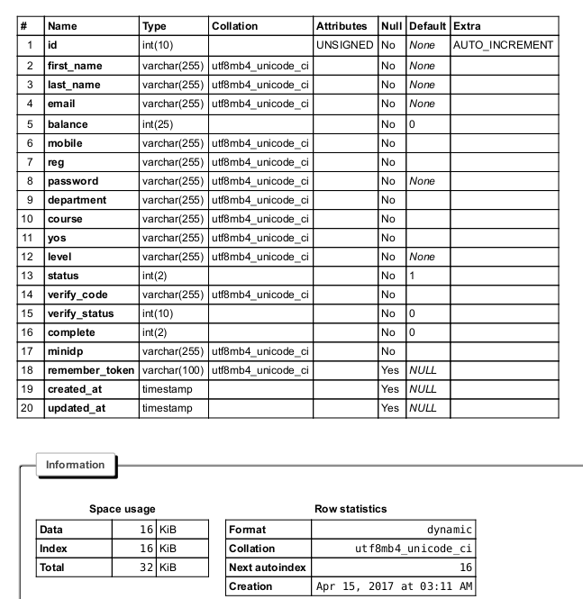

2.1.3.2.1.2 Courses table
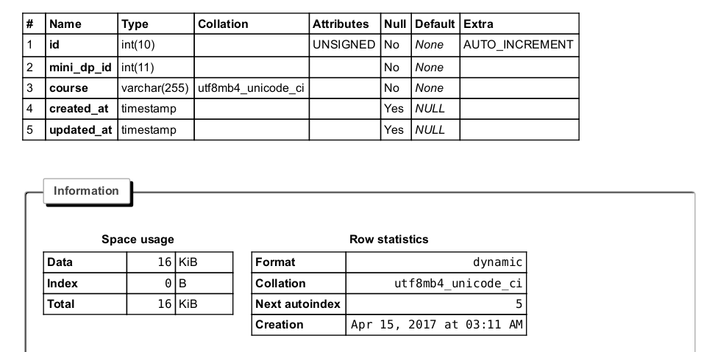

2.1.3.2.1.3 Messages table
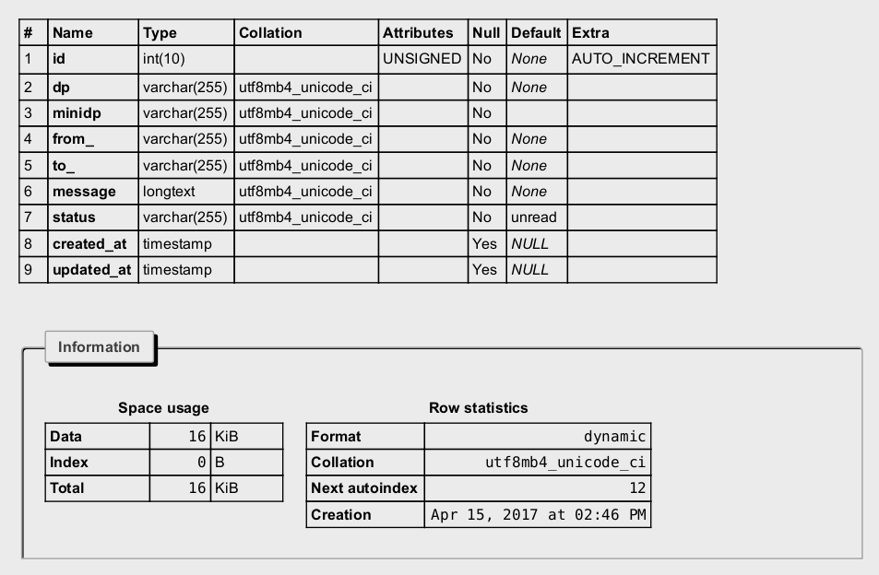

2.1.3.2.1.4 Departments table
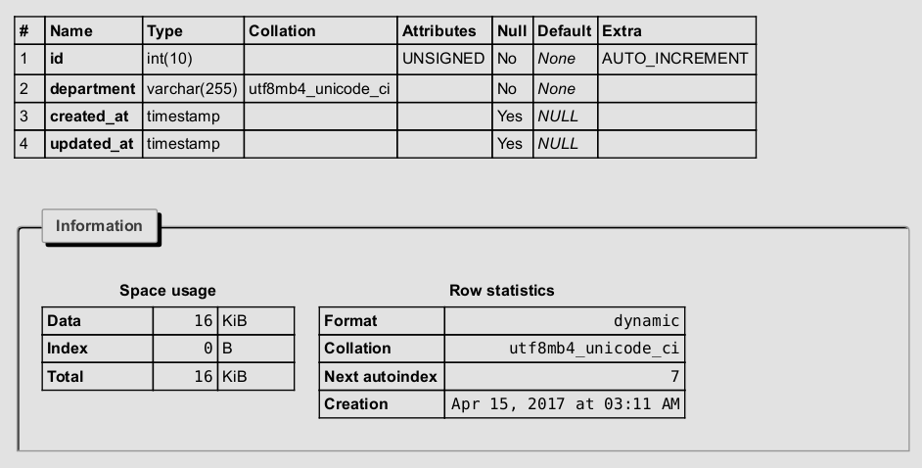

2.1.3.2.1.5 Notices table
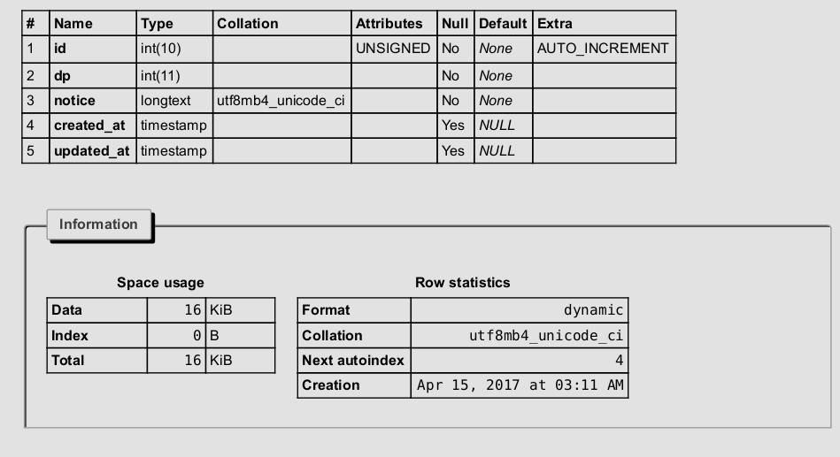

2.1.3.2.1.6 Records table
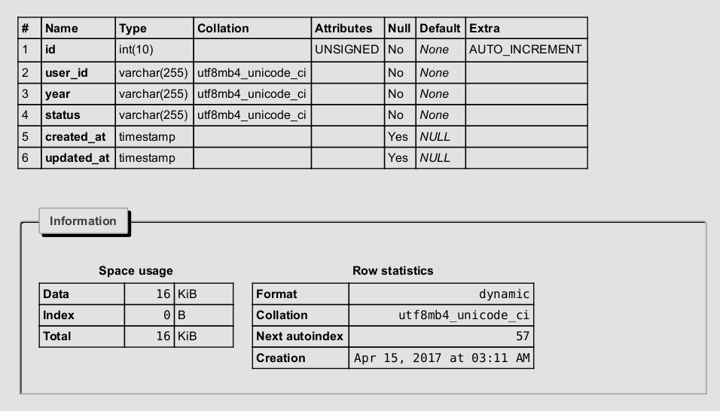

2.1.3.2.1.7 Transactions table
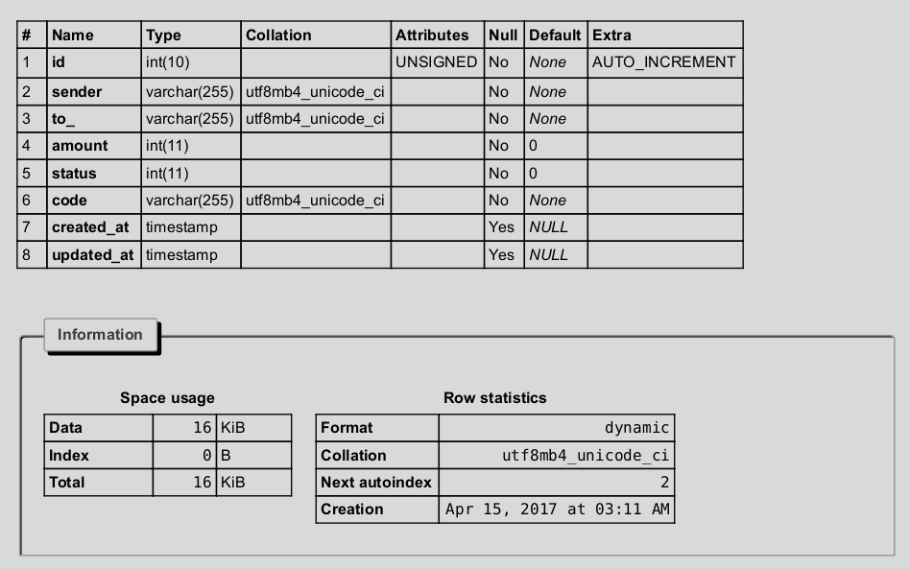

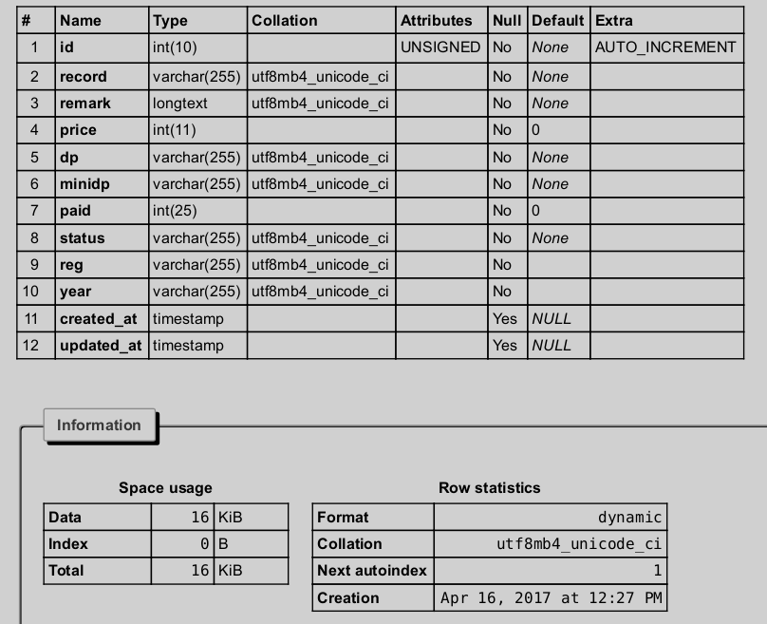
2.1.3.2.1.8 Remarks table

2.1.4 CODING

2.1.4.1 Laravel
To start the coding, laravel library must first be installed in a development folder. To install the library the following steps are followed:-
1.Open the command terminal
2.Go to the directory where you want to project folder to be located
cd /my-project/
3.Install the laravel library
composer create-project laravel/laravel –prefer-dist project_folder_name
NB:-The computer being used to install the laravel library must have composer installed
Project folder structure
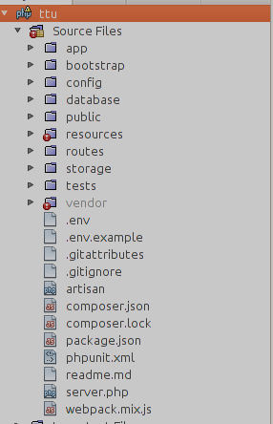
Sample Code is in the appendix

2.1.5 IMPLEMENTATION AND TESTING
The design of the database was similar to the analysis phase. The database has been developed using MySQL. The user interface of the application has been designed using php and HTML. The main controls used in the design are navigation menus and hyper-links.
Sample Customer Login Page
The screen-shot below shows the users login page which is displayed when a users wants to logs in.
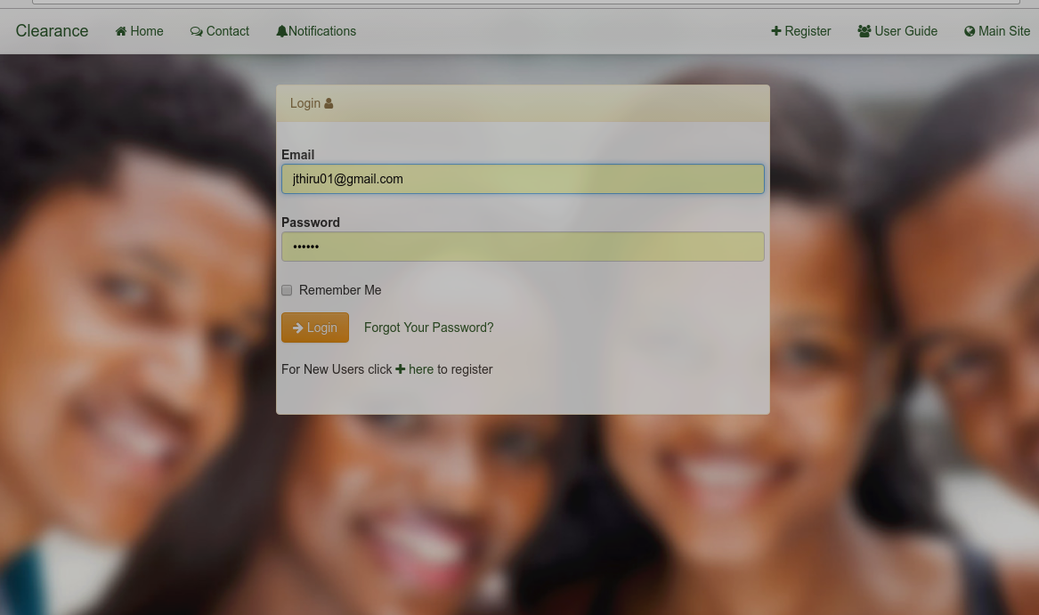
Illustration 1: Login Page

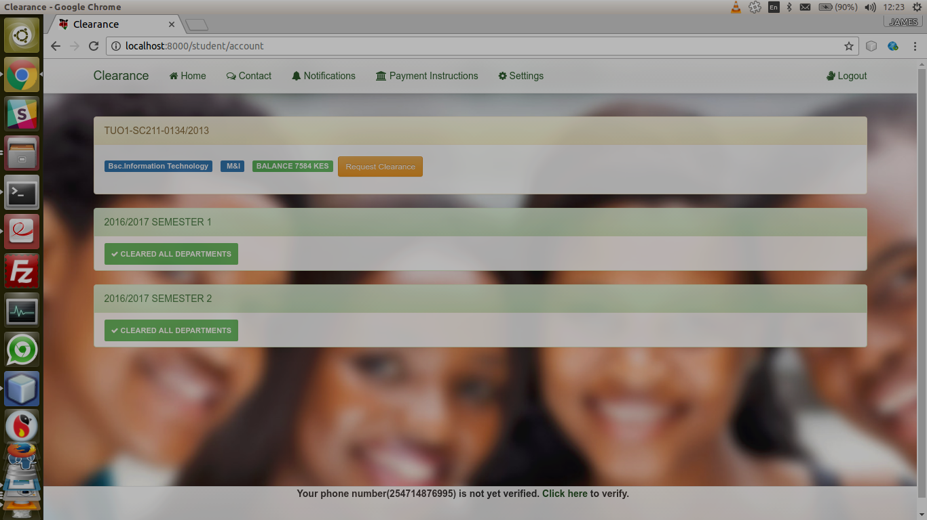
Illustration 2: Student Account

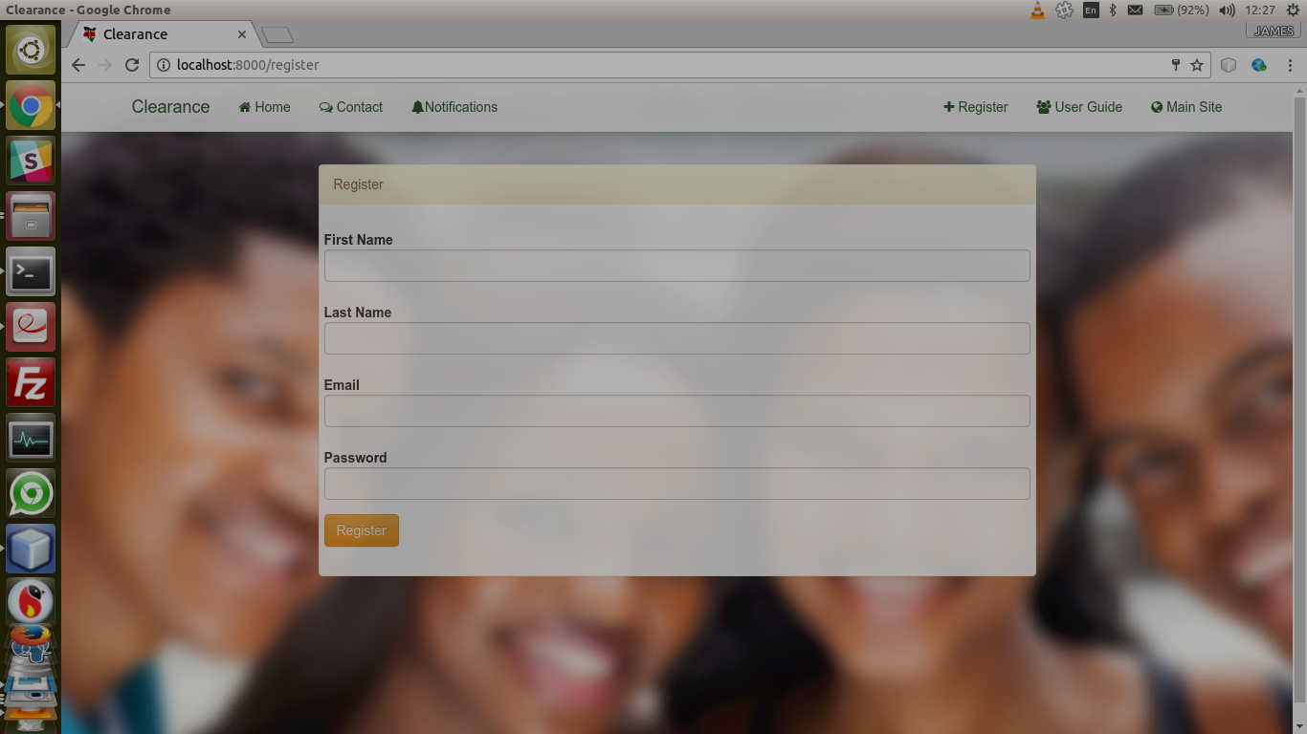
Illustration 3: Registration

2.1.5 Testing
Software testing is a process of running with intent of finding errors in software. Software testing assures the quality of software and represents final review of other phases of software like specification, design, code generation etc.
Testing involved actual execution of program code using representative test data sets to exercise the program and outputs are examined to detect any deviation from the expected output. The objective of this testing was to find out any undiscovered errors and whether the system works as expected. Below are some of the testing that were carried out;-
i. Unit testing
Unit testing is where individual components are tested independently to ensure they operate correctly. This will test each entity and module to ensure it functions as expected. Unit testing emphasizes the verification effort on the smallest unit of software design i.e.; a software component or module. Unit testing is a dynamic method for verification, where program is actually compiled and executed. Unit testing is performed in parallel with the coding phase. Unit testing tests units or modules not the whole software.
ii. Acceptance testing
Acceptance testing is also known as alpha testing or last testing. In this case the system is tested with real data (from students) and not simulated test data.

2.1.6 SYSTEM MAINTENANCE
Some of the main types of System Maintenance are:
i) Adaptive Maintenance: where improvements to the system are necessary to adapt to changing working procedures or legislation.
ii) Corrective Maintenance: where ongoing improvements are made (bug fixing) to ensure the system still meets the original user requirements.
iii) Perfective Maintenance: improving the system so that it becomes more refined and more efficient at processing.

3.0 CONCLUSIONS AND RECOMMENDATIONS.

3.0.1 Conclusions
During the development, the following challenges were encountered:
1.Acquisition of some essential codes – the developer of the system had some difficulties in getting the correct code especially for the payment module which was bulky to implement due to the strict business rules set up the market and the few payment options available in Kenya.
2.Compliance of the project schedule – the developer had numerous difficulties in sticking to the project schedule due to the many demands of other courses, Continuous Assessment Tests (Cats), and final examinations. There was thus a need to have a balancing act of the Information Systems Project with the other courses.
3.Continuous review – the developer had to review numerous project bounds before settling on the most suitable. This was a continuous exercise throughout the project and it required a lot of time and keenness.
4.Numerous Available architectures – The developer had to test the system on the most popular browsers both on mobile and computer.

3.0.2 Lessons learnt
During the development of the clearance system, the system developer learnt some vital lessons which include:
1.The significance of meeting with supervisor – constant meeting with the supervisor aids to keep the project on track and the knowledge gained from the supervisor is immense and it transcends beyond the project.
2.Proper Prior Project Planning Prevents Poor Performance – the 7P’s of project
planning make sense now.
To conclude, the undertaking the system project was an interesting but a challenging venture. From the evaluation of the system, the following were some of the critical points to which the developer noted from the system:
The mobile payment options should be improved to cater different subscribers i.e we have mpesa on hand, yucash ,orange and airtel money to be integrated in the system.
Note: All the recommendations from the evaluation results were possible but due to the challenges stated above, especially the limitation of time, it was impossible to implement. The developer opted to improve on the project when the system is implemented.

3.0.3 Recommendations
Following the system developer’s know-how in undertaking the system project, the developer would like to recommend to the Faculty the following:
The Faculty of Information Technology should have the system project be started on the third year first semester. The Faculty should set aside part of the fees to support students undertaking projects in Third Year because of the money used in logistics such as massive printing.

4.0 REFERENCES

- Cronholm S., & Goldkuhl, G., (2003). Electronic Journal of Information Systems Evaluation. Strategies for Information Systems Evaluation - Six Generic Types, Vol. 6 No.2, 65 –74.

- Farkas D. K., & Farkas J. B., (2002). Principles of Web Design. New York, USA:Long man..

- Robin N., (2009). Learning PHP, MySQL & JavaScript: A step-by-step Guide to Creating Dynamic Websites. 1005 Gravestein Highway North, Sebastopol, CA: O'Reilly Media,nc. CA.

- Tanter E., (2011). Object-Oriented Programming Languages: Application and Interpretation. URL, http://www.dcc.uchile.cl/~etanter/ooplai/ Date: 12.06.2012

- Walsham G., (1993). Interpreting Information Systems in Organisations. New York, USA.Wiley & Sons Inc.

APPENDICES

APPENDIX 1: REQUIREMENTS SPECIFICATIONS
Hardware Specification
The minimum hardware requirement that is required for development is a Pentium 4 computer system with processor speed of 233MHZ, RAM 256MB and hard disk of 1GB running either Windows 7 (and above) or any Linux Distro.
Software Specification
The Student Clearance System will be developed on a computer that is installed with;-PHP 5.6 or a later Version. The system will also require MySQL 5.0.0 or a later version.

APPENDIX 2: SYSTEM INSTALLATION
Installation requirements
Composer
phpMyadmin(for mysql)
Create a new database ,import the database ttu.sql in the project folder
Update the database name in the .env file
DB_CONNECTION=mysql
DB_HOST=127.0.0.1
DB_PORT=3306
DB_DATABASE=ttu
DB_USERNAME=root
DB_PASSWORD=root
To start the run the system run the localhost server on the terminal
:- php artisan server –port=9100
Open the browser and visit http://localhost:9100

APPENDIX 3: SAMPLE CODE
The Classes can be traced from \web\webphp:-sample routes include
Route::get('/student/{id}/pay/claim','Student@pay_claim');
Route::post('/student/send/message','Student@sendMessage');
Route::get('/', 'GeneralController@root_path');
Route::post('/student/request/cert','Student@request_certificate');
Route::get('/payment','Student@payment');
Route::post('/verify/mobile','Student@verfiy_mobile');
Route::get('/resend/code','Student@resendCode');
Route::get("/admin/department/{type}/{id}/delete",'Admin@delete_dp_admin');
Route::get('/about','Student@about');
Route::post("/admin/edit/department",'Department@edit_department');
Route::post('/admin/edit/minidepartment','GeneralController@edit_mini');
Route::post('/save/profile','GeneralController@save_profile');
Auth::routes();
Route::post('/verify/payment','Student@verify_payment');
Route::get('/admin/resend/{id}/code','Admin@resend_code');
Route::get('/admin/finance/report/unpaid','Admin@unpaid');
Route::get('/admin/finance/transactions','Admin@transactions');
Route::get('/admin/finance/report','Admin@report');
Route::get('/admin/approve/{id}/id','Admin@approve_save');
Route::get('/admin/requests','Admin@requests');
Route::post('register/new','GeneralController@register');
Route::get('/admin/students','Admin@students');
Route::post('/admin/add/minidepartment',"Admin@add_office");
Route::post('/admin/add/department','Admin@add_department');

APPENDIX 4: EXAMPLE CLEARANCE FORM
